Oops, I Did It Again!
Matt Vienneau
For part one of this article, click here.

The First Draft
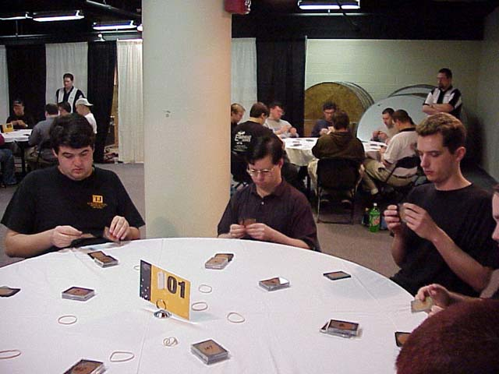
Mike Pustilnik is on my right, and Brock Parker is on my left. I know Mike has a preference for blue, so I'm aiming to avoid it if possible. My first pack has a variety of decent spells in different colors and I go with the always-solid Spite/Malice. The next couple of picks give me a variety of black cards and I'm not seeing any blue cards (as I expect) but I'm also not seeing any red cards! The black cards are coming through nice and clear, but by the end of the first pack the only non-black card I have is a late Shivan Zombie! I've been passing some nice Green-White through to Brock though so I'm hoping for second-pack goodies from that side.
The second pack gives me Agonizing Demise and I get passed an Annihilate, so obviously the signals went through. But still the red and/or blue aren't coming. After two packs all I have are black cards, a single Shivan Zombie, a Rogue Kavu and a Kavu Aggressor. I'm getting a bit worried at this point.
But I had forgotten that Planeshift is all about red. I have a new draft theory that you can always go Black-Red! The black cards are plentiful in Invasion, so you'll end up with good stuff in the first pack as long as both players to your right aren't drafting black. If you've blocked off the Black-Red cards successfully then you should be rewarded in the second pack when it comes from the other direction. And in the third pack, no matter what, you'll end up with lots of good red cards because red is so amazing in Planeshift! It was the perfect strategy for me and I attempted to use it for the rest of the day.
Planeshift gave me seven playable red cards including the Terminate I opened - something I would repeat the next draft. But my draft deck still ended up worse than the sealed deck from the day before. I have passed Brock at least three really late Gerrard's Commands to go with the many other good Green-White cards that he picked up the first time the packs went around, so I know his deck is excellent.
I'm not going to bother listing the deck because there was nothing atypical about it. It was a lot of bad creatures (are there any other kind in Black-Red?) and a lot of decent removal. They key to the archetype is making sure you have enough kill and that it's good enough. Two Tribal Flames and a Cursed Flesh is not enough. Spite/Malice, Demise and Annihilate with various supporting kill probably is.

Round 9 - Peter G Szigeti
I don't recall much of this match, though I believe I won without using my many banishes, which surprised me. After 14 rounds of playing black-red decks, it's hard to remember something special about each one! I do remember thinking "wow, Mire Kavu is a beast!"
8-1

Round 10 - Adam T. Prokopin
I spent way too long trying to fall asleep the night before, and while I tossed and turned as neighborhood kids held a party in the motel parking lot, I planned out my second day. 2-1 in the first draft, and then win the first two matches of the second draft and draw into the Top 8. Seemed like a reasonable plan. And so far, everything was going according to plan. So I start getting confident.
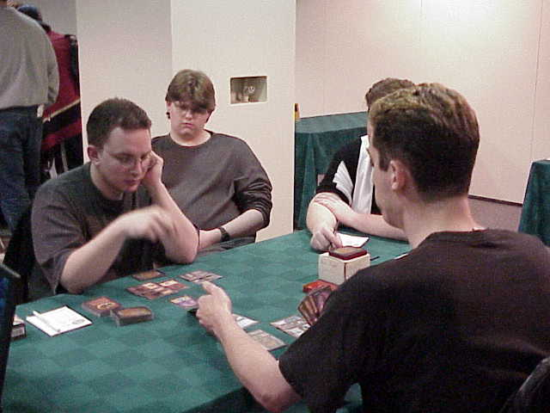
And as we all know by now, when I get confident, I lose.
But to my credit, I didn't misplay this one. The first game, I keep a two Swamp hand and miss my third land drop. I play another Swamp on turn four and then miss a land drop on turn five. By turn eight or so I'm flush with Swamps as I'm able to cast Necropotence with two black mana left over for the Hymn. Unfortunately I left those in my sideboard and I'm only holding red cards, so I get crushed.
No problem, I think, I'll just win the next two games.
Second game, I keep a hand with two Mountains and I figure that at least I won't lose because I can't cast a red spell. As you might expect, after missing my third land drop again, I draw a third Mountain, miss another land drop, and rapidly get defeated, as my late-game Swamp proves too little, too late.
I try and keep my antics humorous as I curse the world and I'm apparently successful, as Adam can't help but smile. This doesn't make me feel any better, but it's better than leaving my opponents feeling sucky.
8-2

Round 11 - Brock Parker
I was feeling really crappy at this point, as I now had to win my next three matches to make Top 8. I'm not confident enough in my draft abilities to do that. And to make things worse, now I'm facing the guy I fed an amazing deck to.
Of course, I was overlooking the fact that Green-White just isn't as good as Red-Black!
Some combination of kill and early creatures allows me to take the first of three matches I'd end up playing against Brock, and I'm still on track to make Top 8 with 2-0-1 in the final draft!
9-2

The Second Draft

Never listen to your brain...
My opening pack provides an interesting set of choices. It's no Faerie Squadron vs. Duskwalker decision, but it's still a lot of fun. The choice is between Phyrexian Infiltrator, Repulse and Duskwalker along with a Pincer Spider or something. I know if I take the Infiltrator, I'll be fighting for blue and black with the people on my left. If I take the Repulse I'm in Blue-White and I don't like to go Blue-White without opening a bomb in the colors like Rout. If I take the Duskwalker, it allows me to go Black-Red knowing that red won't be taken at all on my left, while the black will still trickle through. Seems pretty simple!
So of course I take the Infiltrator.
Why? Well, I like to play with my gut, but while my gut may have been hinting "take the Duskwalker" I couldn't convince my brain that taking the 2nd tier card over the 1st tier cards was the right play. Never listen to your brain, it's got nothing on your gut!
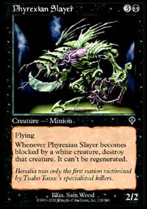
To make things worse, the Infiltrator is hard to splash blue for, so I'm pretty committed to blue. So later I take an Urborg Emissary over a Phyrexian Slayer as I'm thinking I'm Black-Blue. The problem is that I'm ignoring all of my own advice. Whenever you're drafting blue, if you don't see decent blue commons like Repulse, Exclude or Faerie Squadron in the first 4-5 packs, then someone on your immediate right is probably playing blue, if not two people. I don't see any of these cards but I'm so focused on drafting Black-Blue that I ignore the signals like some sort of idiot. I became too attached to my first pick, despite my advice just weeks earlier on the Sideboard to ignore it if necessary. Talk about a horrible way to draft!
After the first pack, the only other blue card I've got is a Dream Thrush and a Traveler's Cloak while I've picked up a nice juicy Hooded Kavu (that's sarcasm) in red. So, being a highly-skilled drafter, when I review my cards after the first pack I should obviously become aware of the fact that the blue isn't going to be coming through, right? With what I've learned about Planeshift red in the first draft, I should assume that I'll be going Black-Red starting with the second pack.
Again, I take the road less traveled (only because no one else is that stupid) and keep taking blue cards over red ones. I pick a Faerie Squadron first and then take a Fact or Fiction over something decent such as Scorching Lava. But the blue dries up and I'm forced to pick up some 3/1 Viashino Grapplers late. My indecision and color-switching is hurting me throughout the entire back and at one point I take a late Phyrexian Reaper over a second Shivan Zombie, a choice I regretted for the rest of the draft. Ironically, the Reaper wins me the match in the 12th round!
After two packs, I've got a horrible B-R-U deck that has hard-to-cast blue spells, mediocre black spells, and a lot of really bad red spells and early red drops that are difficult to splash. My dreams of 2-0-1 are looking extremely grim.
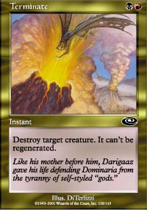
Again, Planeshift saves me. After reviewing my horrible draft after the second pack, I finally wake up and decide to go Black-Red and ignore any blue cards that make it to me. Planeshift blue isn't that strong so I'm not worried about getting too tempted. I manage to pick up nine easily playable cards including Terminate, two Mire Kavus, a Caldera Kavu, two Volcano Imps and a Lava Zombie. But it also includes two Morgue Toads! My deck is still horrible as it consists of eighteen creatures and five spells including two Cursed Flesh and a Recover. As I mentioned above, the key to Black-Red is lots of quality kill and a bunch of creatures. I had a bunch of creatures, so I guess I was halfway there! As long as my opponent doesn't play any good creatures or 2-for-1 card advantage spells, I figured I might be able to pull it out.
Ironically, I don't use the Squadron, Fact or Fiction or Infiltrator in my deck. And I'm using the Urborg Emissary only because it's a 3/1 for three mana and I figure I can only win by playing creatures quickly and rushing. I have the Reaper in the sideboard as for only three mana I can get the same power in Urborg Phantom!
We find out later that Huey passed Bob a Pyre Zombie first, and we all envy Bob for having such great friends!

Round 12 - Dan Clegg
Another feature match! There's nothing more exciting than watching Dan play, so I can see why they picked us! Why watch glaciers melting when you can watch Dan play Matt?
Seriously, Dan's a great guy and we had good times later during the Top 8 antics.
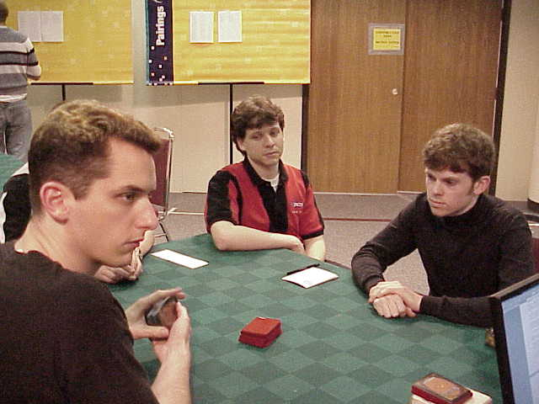
I manage to get some great offense going early on as Dan doesn't get his third (of four?) color and is unable to cast spells he seems really eager to get out. I'm doing fine as long as he doesn't play anything that can kill my 2/2s and 3/1s!
Dan finally casts a creature - Magnigoth Treefolk! Well, I've still got a bunch of flying Gray Ogres that can get through.
His next play - Ancient Spider!
Things rapidly go downhill as I can't find my lone Terminate and Dan removes my two bigger creatures with a Magma Burst. After the tree puts on an Armadillo Cloak and starts gaining life for the team, I'm quickly put out of my misery. Can anyone explain to my why attaching a bunch of Armadillos to your jacket somehow allows you to start gaining life?
** Aside on Armadillos **

Far be it for me to write an extensive tournament report without doing my research! In my attempts to determine if an Armadillo was a Marsupial or Rodent or neither I had my many research assistants working diligently throughout the night. While I can only say with assurance that it is a mammal, I can also tell you quite confidently that the nine-banded armadillo, or dasypus novemcinctus is "a cat-sized, armored, insect-eating mammal. Similar in form to an anteater, the bony, scaled shell of the armadillo protects it from attacks by predators. Unfortunately, armadillos often fall victim to automobiles and are frequently found dead on roadsides." For more information, feel free to rush to www.tpwd.state.tx.us/nature/wild/mammals/dillo.htm. Now all your small/talk worries are covered for your next party!
I still fail to see how wearing Texas road kill somehow makes a creature more powerful and able to gain life with every blow! But can anyone deny that "Texas Road Kill" would make an excellent name for a band?
** End Aside on the State Mammal of Texas **
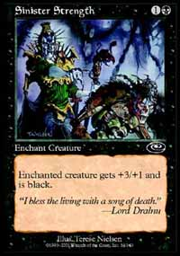I do my standard sideboarding of removing the Toads and a Phantom for Firescreamer, Phyrexian Reaper and Sinister Strength. Dan drew his Magma Burst and Cloak again, but I had Terminate this time and pulled it out. The third game saw the Ancient Spider again but Terminate saved the day and despite his Magma Burst, I was able to win the match as Dan was holding an Armadillo Cloak he couldn't play. The key play of the game was the Phyrexian Reaper forcing the Treefolk to block and destroying it with the special ability! I'd like to see one of those over-hyped Shivan Zombies take down a 2/6 creature!
Dan is visibly upset that I had the Terminate when I needed it in the 2nd and 3rd games, but I point out that he had the Magma Burst every game so he has nothing to complain about!
10-2

Round 13 - Brock Parker, round 2
I just had to win this match and I could draw into the Top 8!

My deck is so bad I don't want to risk playing if I don't have to.
Unfortunately, Brock had a good deck with only two or three colors and he beat me down viciously. At one point in the first game, we're both top-decking and I've got board advantage and Brock peeled three or four top cards in a row and took the game. The second game had me mulligan and then get hit by double Bog Down, dashing my Top 8 hopes, despite my desperate gamble of splashing blue off an Island, Sulfur Vent and two Morgue Toads for Fact or Fiction in order to compete in card advantage. I can't complain as a superior deck wielded by a good player defeated my deck, but I was angry with myself for getting so confused during the second draft.
I was feeling pretty glum.
10-3

Round 14 - Ed Linskey
The standings go up and I'm standing there trying to figure out whether I can draw into the Top 16. My deck is so bad I don't want to risk playing if I don't have to. As I'm standing there, Dan (Clegg, if you're having trouble following the cast of characters) walks up and mentions that if I win, and Justin Schneider loses, my tiebreakers are the best so I'll come in 8th! No draws for me!
In hopes of getting the sympathy concession, I take great pains to point out to Ed that he has no chance of making Top 8 (he has the worst tie-breaks of the 30 pointers) while I would really like to make Top 8. But it's not really a convincing argument as Ed doesn't know me from an armadillo and he's not likely to make Top 16 if he concedes (he ended up 24-26th). Dan walks by and mentions that he's won his match so if I lose he's in the Top 8 instead. Since Dan and Ed apparently know each other, my hopes of a concession go down the drain.
Of course, the more discerning readers will be wondering what weird Twilight Zone I'm in that has Dan Clegg apparently finishing his match before I did!
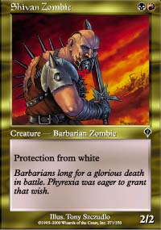
The first game sees me go down in flames. I can't handle a late game, and he's able to match me in the early game. While doing the standard sideboarding for the second game, I'm praying for an opening hand Shivan Zombie with Sinister Strength against Ed's deck of mostly white creatures.
Well, you can't win a Grand Prix without a little help and I'm helped out by a 5/3 pro-white creature on turn four (hey, you can't ask for everything - turn three would be greedy!). It goes all the way as I Scorching Lava his sole Green blocker in response to a Gerrard's Command. I could have played it safe on turn four and dropped a Lava Zombie over the Sinister Strength, but you have to play to win and I didn't have much of a game after that with only three land and a lot of 2/2 fliers for four mana.
So it all comes down to a third game - if I win I'm in. (Or so I'm telling myself.)
My opening hand has the Sinister Strength, but no Zombie. Luckily, on the second turn the Zombie comes to play against his Llanowar Knight that all the black spells in my hand can't deal with. He hits me for two and says go. I Sinister Strength the knight, hit for five, and tell him "don't draw the Strength of Unity!"
Sure enough, I'm not the only guy getting help at this Grand Prix and Strength of Unity comes down on the unstoppable Knight and all of a sudden it's 13-15 and I'm in a race that I may not win!
I play a 2/2 flier to help the race out, but it's not going to make a difference as I knock him to 10. He deals with the flier and hits me for five and I'm starting to worry about other tricks like Gerrard's Command. If he has it, I'm dead unless I draw a red creature!
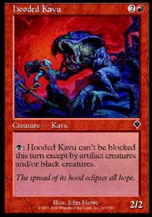
I draw - and it's the Hooded Kavu I mocked earlier! I attack for five to put the life totals at 5 (him) to 8 (me). Now I have a choice, do I play the Kavu and chump block, assuming he has the Gerrard's Command that will finish me off? Or do I play the Phrexian Reaper so there's no way he can play a green creature and stop me from winning as I can chump block with the Hooded Kavu the next turn?
I ponder the play for a while and decide that it's best to play the red creature. I can't play around a mythical green creature that he hasn't cast in the first five turns and expose myself to a creature enhancement spell that I saw in the first game.
This turns out to be the correct play as Ed did have the Gerrard's Command but no green creatures so I'm able to take the game! It's an incredibly relief and I slump to the table as the stress floods out of me.
11-3

Top 8 - The Craziness Begins!
Here's where we get to the sordid stuff.
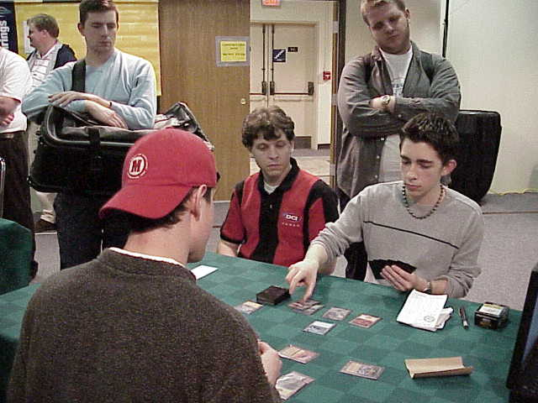
I go look at the standings again and someone has filled in who has won what matches. As I was stressing out over my final match what I conveniently forgot was that I was only in the Top 8 if Justin lost his final match. But he won it! I was not in the Top 8 after all; I was to finish 9th!
Normally this is crushing for people to be ninth. But I've got two things making me feel better:
1) I didn't expect to go 2-1 with my final deck, so I'm just happy to be here; and
2) I thought I was out of contention after round 13 so not making it in with only 30 points isn't all that much of a surprise as normally you need 31 anyway.
I was still hoping for some sort of surprise so I hung around trying to "come down" from the tense final game of my last match. As everyone sat around waiting, the round ended, but there appears to be some sort of problem. Eventually it comes out that the judges suspect Justin Schneider of bribing Ben Stoll, his final round opponent!
Apparently Ben was automatically in the Top 8 while Justin needed to win. So Justin worked something out with him and Ben threw the match. The problem was that it was a feature match! Apparently Ben didn't know how to do lose the match subtly, drawing a lot of attention to himself. Reports have him taking mulligans with fantastic opening hands and not blocking so he'll lose.
At past events where this has happened, the judges haven't done anything with the argument that they can't be the arbitrator of bad play. There's always the chance that the player just cracked under the pressure - there's no way to prove that someone is throwing the match. If I hadn't won Grand Prix-Dallas, it would be interesting to see if people would have accused me of throwing the finals after killing myself in the third game!
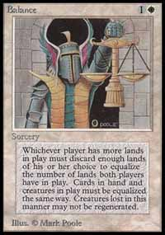
But Mike Donais is not your average judge, and he deserves tremendous respect for it. He took the riskier, but correct, path by disqualifying both players as there's no way anyone would play that badly at this level. And while I would never advise lower level judges, or judges without extensive play experience, to make these sort of decisions, I believe Mike definitely made the correct one. Of course, I also benefited greatly, so I'm hardly an unbiased source!
For the entire hour and a bit that the judges used to make the ruling, Dan Clegg (who was 10th) and I sat around waiting hopefully. While we didn't want someone disqualified if they weren't cheating, if Ben had played and won the match I would have been 8th so I had no sympathy for players who would cheat and knock me out of the Top 8!
As Scott Larabee walked by to announce the Top 8, he suggested to Dan and I that we stick around and we both had big grins on our face even before they announce that we're now 7th and 8th!

Top 8 - The Drafting Begins
As Bob Maher and I agreed in the semi-finals, the sweet spot in any draft is to the left of William Jensen! He didn't pass me a Pyre Zombie like he did to Bob, but he definitely made his signals clear and easy to read and he didn't block off any key cards until the final picks.
My opening pick is between Recoil, Repulse and Pincer Spider. I know the Spider ensures I won't be competing with the players on 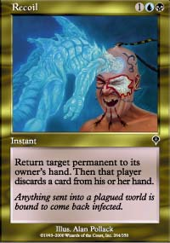my left, but after my first two drafts and my sealed deck my goal is to draft Black-Red. Unfortunately Recoil and Repulse don't really give me that option. Recoil is closer to Black-Red, but Repulse is the better pick as it leaves my options open. If the black cards just don't come I can always go Blue-White!
** Aside on apparent inconsistencies in my draft strategies and theories **
The more perceptive of you (not to be mistaken with the more astute and more discerning) may have noticed apparent contradictions in my draft theories from one draft to another. While it certainly looks like I just said in the second draft that I hate to go Blue-White without a bomb, and then contradicted that entirely by taking Repulse and potentially going Blue-White, the reality is much subtler. But I'm hardly known for my brevity as it takes me 3,000 words to explain even the simplest of draft strategies. So if I were to explain in detail the exact thinking at every step, you'd miss the entire hockey playoffs reading it. Since no one wants that to happen, I'm forced to give the salient points in my thinking at each juncture, with the acknowledgement that each situation is different and there are often tiny variables that I don't have the space to mention that change what I do.
** End defense of apparently random drafting strategy **
I'm rewarded with a Recoil from Jensen who took Sparring Golem over it (he apparently doesn't like black-blue!).
Next he passes me Shivan Emissary! There are few signals as strong as a third-pick Shivan Emissary. It was too good a card for Jensen to have missed this early, so he was obviously not playing Black-Red, and it was extremely unlikely the person to his right was playing Black-Red either unless he opened Pyre Zombie. I don't recall if I checked the rarity of the missing cards or not, but I should have.
A pick or two later I get a PROBE! A fifth pick Probe is another excellent signal, but what sort of draft is it when all the signals are saying that no one is playing Black-Blue-Red? I finish the first pack with more good cards in those colors, but few creatures. I didn't see any decent red cards other than the Emissary so I suspect Jensen is playing Red-Green but even then I'm surprised he didn't splash black for the red banishing.
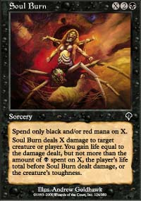
The second pack just goes crazy for me. I haven't passed any red cards to the left so I get rewarded with TWO Soul Burns and TWO Plague Spores, all of which come late. I also get another Recoil! At one point, I have the choice between my THIRD Recoil and Urborg Drake. I don't know what colors are going to be my main (Black-Red or Black-Blue) but I know I'm short on creatures so I go with the Drake. I end up not playing it as blue is my splash and it's not really a splash card like Recoil is.
The other choice I probably screwed up was taking Tsabo Tavoc over Phyrexian Slayer. I like Tsabo a lot, probably too much, but it's incredibly expensive. If it gets into play, you're generally in really good shape. But at the time I didn't know I'd end up with so many really expensive spells in my deck and it ended up being too expensive to fit in.
I was a little worried about my mana, so I took a Phyrexian Lens late but I ended up not playing it as my deck was too slow to take the damage and I'd rather have the more dependable 18th land. I also had a Bloodstone Cameo but didn't expect to use it with so many three casting cost spells in my deck.
Planeshift was good to me, as it always is, with a Magma Burst, but it dried up after that except for a Thunderscape Battlemage. At least, it dries up until the 5th pick Stormscape Battlemage! Woah! And that's followed by a sixth pick Rushing River! I look over at Jensen and he just shrugs, but I already know he's my best friend ever!
My final deck looks something like this:
The Kill:
2 Soul Burn
2 Plague Spores
Shivan Emissary (for those pesky Obsidian Acolytes)
Stormscape Battlemage (for those pesky Crimson Acolytes)
Magma Burst
The Bounce:
2 Recoil
Repulse
Rushing River
The Discard:
Probe
Thunderscape Battlemage
The Combo: (with CIP creatures)
Nightscape Apprentice - MVP! The red ability held off the attackers and the blue ability gave me infinite discard and kill.
Lava Zombie
The Chumps:
Phyrexian Bloodstock
Duskwalker
Firescreamer
Morgue Toad
Kavu Recluse
Shivan Zombie
Nightscape Familiar
In my sideboard - Hypnotic Cloud (too expensive), Tsabo Tavoc, Urborg Drake, Urborg Skeleton, Gainsay, Metathran Zombie and Arctic Merfolk.
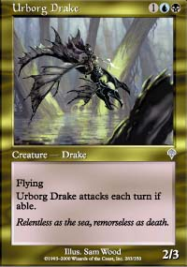
My theory during deck building was that my deck had so many incredible spells that the longer I survived the more likely it would be that I would win. I was vulnerable during the early game, but as long as I could survive until I had six mana, I should be okay. So a bunch of the sub-par creatures are in there just to buy time for the late game. The Urborg Drake isn't really good at buying time, as it's more of an offensive tool, so it got put to the side.
The other issue was mana. I wanted have red or blue as a main color with the other one a splash, but neither color is an obvious splash. I finally decided to splash both colors using the Morgue Toad and double Sulfur Vent with only five Islands and five Mountains to my eight black sources. I tried to cut down on early blue and red drops but I was desperate for creatures so some of them made it in.
I had the option to include either the Metathran Zombie or the Urborg Skeleton but I didn't think I'd have the mana to regenerate them consistently with all my expensive spells. Four mana for a 1/2 creature just doesn't cut it when it can't regenerate, and a 1/1 for two mana in my off-color isn't such a great deal either.
Throughout the Top 8 I never did any sideboarding. Tsabo and the Skeleton almost made it in once or twice but I always decided against it.
As I finish building my deck, Gab Tsang takes a long look and says he'll see me in four hours when I'm done with the finals. Encouraging words indeed!

Quarterfinals - Adam Prokopin
I'm keen to play Adam again as he was the one who had defeated me earlier when I drew one color of mana and missed my third land drop in two straight games. He also refused to roll my Inquest dice to determine who would go first. I've been using the dice for six years now and let me warn my future opponents, not rolling the dice has a direct causal relation to losing the match. It's about a 95% predictor!
I also don't really know Adam so I'm hoping that he won't have drafted as good a deck as some of the more experienced players at the table.
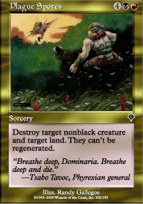
Adam put me in an interesting position in the first game when he went many, many turns without drawing a Swamp. I removed all of his red creatures, and even destroyed a Mountain, but I ended up sitting there with six or seven excellent kill spells and unable to take advantage of the fact my opponent was horribly mana-screwed! I was just waiting him to draw another red creature so I could use Plague Spores to destroy another land!
Eventually I succumb and play the Stormscape Battlemage with no kicker and a Rushing River in hand to bring it back if necessary. But it turns out not to matter as I remove all the blockers and essentially kill him with the Battlemage, one Firescreamer attack, and a Soul Burn over the top.
Throughout the entire game I was very aware of only having twelve creatures in my deck and I was constantly making sure I had enough left in my deck to actually win the game. The second game really brought this conflict to the fore, as I had to choose whether to block a Maniacally Raged 5/3 Rogue Kavu on turn three. I had my Shivan Zombie and Nightscape Apprentice ready to sacrifice themselves but they made up 16% of all my creatures! I also had a Recoil and Rushing River in hand but no Islands so I had to decide whether I wanted to risk waiting for an Island and taking a lot of damage, or sacrificing two of my limited threats in order to keep my life total high.
I decided to play it safe, as I know I'll win the long game, but I don't want to lose to a 5/3 because I can't draw an Island. I traded creatures and then naturally the top card reveals itself to be an Island in order to taunt me. My deck was very good to me after that as it brought up creature after creature, but I was also very aware of Adam's Magma Burst. I played around the Burst by never having my two best creatures in play (there was a lot of gating and bouncing going on) and eventually worked my way through it, dropped more creatures, and overwhelmed him. It doesn't take much to win when every time your opponent plays a creature you kill it and get card advantage at the same time!

Semi-Finals - Bob Maher
"Matt must be the best drafter in the world, have you ever seen him play?"
- Most People Who Watch Me Play
Playing Bob is always a treat for me. He's a nice guy and we trash talk back and forth and have a good time about it. Unfortunately this often lulls me into a state of relaxation and I pay the price in my playing ability. Lucky for me, if it's an important match I tend to win anyway! The key to beating Bob is making so many mistakes that he gets frustrated and then draw much better cards than he does.
Randy Buehler covers the match on the Sideboard here.
I played Bob in a feature match in Tokyo and Randy covered that match as well, so it was like old friends getting together once again to see if I could play badly and still win. I'd like to take a moment to go through some of the mistakes that I did and did not make. One of the difficulties in doing coverage is that you're naturally not as familiar with the players' decks as they are, so what may seem to be an obvious play to you, may be incorrect for that particular deck.
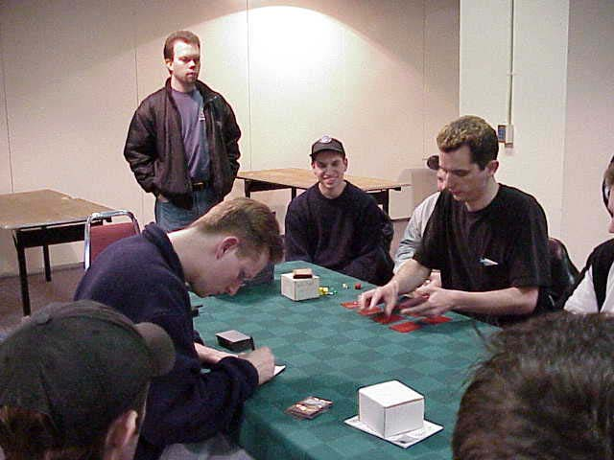
Randy was a bit critical that I didn't seem to be aware of the red ability (First Strike) of the Nightscape Apprentice. There were times when I could have used the threat of First Strike to get through Bob's half dozen creatures with my Thunderscape Battlemage. But if I do that, and Bob has any sort of removal for my one 3/3 blocker, then I'm totally screwed. I can't afford to risk taking damage when I'm still trying to take control of the game. And the last thing I want to do is go low on life because I want to knock Bob down to 18! What if he has a Ghitu Fire or other form of direct damage?
It turns out Bob did have Meteor Storm, though I didn't see that until the later two games.
The other errors are totally mine. I definitely DID Soul Burn an active Thunderscape Apprentice that tapped and saved itself even though I had the extra mana. I had so many decent kill spells in my hand that it didn't bother me that much. If anyone has lots of experience at making big errors in big games, it's me, and I just shrug them off now. How would YOU fell if your opponent just threw away Soul Burn and it doesn't seem to bother him at all? How good would you think his hand was?
I then made several mana tapping errors due to the Nightscape Familiar in play. What can I say? I'm a big dork that way - I made the same mistake at Pro Tour Tokyo. I have the cards burned into my mind, so I know exactly how much they cost to play and that costs me when it comes to Familiars. To be fair, apparently Bob made the same mistake at one point but no one caught it.
I still smile when I think back to discarding Soul Burn and Rushing River to Probe. The look on Bob's face was priceless when he saw how good the cards I *discarded* were. He may have an unreadable poker face, and he may be the master of misleading his opponent's by acting like he's lost right before he wins, but at that point I was pretty sure I had him.
I'd like to address an incident that Randy didn't mention in his coverage. After making myself vulnerable due to my poor mana tapping, I had to sacrifice a Sulfur Vent to cast Magma Burst. So I tapped two Mountains and the Sulfur Vent and then let go of the Sulfur Vent to select the other two lands to sacrifice for the kicker. Bob felt that by letting go of the Sulfur Vent I was choosing not to use the sacrifice ability for two mana and thus had three mana in my pool and Magma Burst in hand.
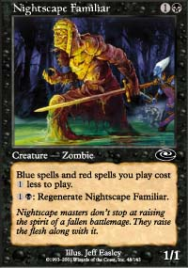
Can't you count?
Mike Donais ruled that what I was doing was an acceptable shortcut and method of casting spells and using mana. I'd like to take this moment to reassure Bob, who I greatly respect, and anyone else who may have doubted me, that all I was doing was reaching for the other two lands to sacrifice. Bob suspected that since I kept forgetting about the Familiar early in the game, that I was trying to pay one less for the Burst now, despite the fact that the Familiar had been killed. As we all know, I'm hardly one to hide my mistakes, so if I had honestly screwed up, I'd admit it. I fully intended to cast the Magma Burst for the full four mana by sacrificing the Vent and two additional lands.
The jovial tone of the match turned a bit sour at that point, which was probably better for me as it allowed me to concentrate on the game. The second game had an interesting attack phase where I apparently misblocked a Yavimaya Barbarian that was 3/3 due to an Elvish Champion. I was fully aware of the Champion in play but I also knew that Bob would think I was a scrubby enough player that I would make a mistake. If there's one advantage to having a reputation for really bad play, it's that occasionally you can pull off really good plays because no one expects them from you! I had a Rushing River for the Champion so I was able to kill the Barbarian without losing my creature.
The third game went according to plan as my superior cards were able to recover from his early rush and I took control and won with the help of a Lava Zombie off the top. To be fair to me, my deck was fully capable of winning without the Lava Zombie, but the Zombie certainly made it easier.

The Finals - Brock Parker, round 3
Oops!...I did it again,
I played with your heart, got lost in the game
Oh baby, baby
- Popular Artist and Obviously Budding Magic Player ("got lost in the game?"), Britney Spears
The finals for any Grand Prix are intended to be best three games out of five. But traditionally the two finalists choose to play three games. I've never understood that as it seems to me that you want to minimize the luck factor by playing as many games as possible. This reasoning paid off greatly in Dallas as I threw away the third game and would have lost a best two of three.
With that in mind, I think we all know why I would want to play best three out of five again.
This is the sequence of spells I played in the first game:
Nightscape Familiar
Thunderscape Battlemage
Soul Burn
Soul Burn
Magma Burst (with kicker)
Plague Spores (targetting his only Island)
Lava Zombie
With that sort of draw, it's very difficult for any deck to last long, and my deck was able to have those sorts of draws all day!
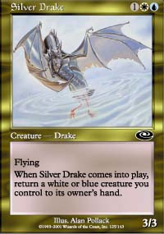
Game two gave me a slightly worse draw but included Nightscape Apprentice and Shivan Emissary so I could draw an endless supply of red banishes against Brock's Blue-White deck. But I only opened with two land and I needed to draw three land by turn five in order to combat Brock's two Silver Drakes.
My first two draws were spells, so I needed a land on my third draw or I would be in serious trouble. I drew...a land! I played the land and Recoil to buy time. I drew my fourth card, another land! I Recoiled again. Brock took FOREVER to decide which card to discard. When he was done, I look at my tapped lands and said "done" without thinking.
I FORGOT TO PLAY THE LAND.
I'm a big idiot!
I don't want to reveal what I've done so I just look to the sky in exasperation for a moment and try and concentrate on the game as the people behind me react in quiet horror.
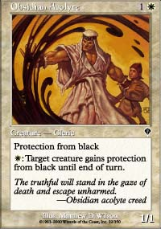
Forgetting the land won't hurt as much if I don't draw the fifth land in my next draw, as I can still play it and be in the same position. But of course I draw the fifth land so I look like a big moron. I end up doing nothing on turn five and Brock plays an Obsidian Acolyte.
I then proceed to throw away the game by using the Shivan Emissary to destroy a Silver Drake instead of the Acolyte. I realize my mistake when I attempt to use the Nightscape Apprentice to put the Emissary on top of my library during my upkeep (having drawn the sixth land I needed the previous turn) and Brock makes the Emissary Protected from Black.
Uh oh.
Only then do I realize just how badly I've screwed myself. I took a game that I easily had in hand and gave it right back to him. Not only did I forget to play a land, I didn't even see the play that defeated me until Brock did it! Not my proudest Magic moment let me tell you. I still have some outs like Magma Burst and Stormscape Battlemage, but I don't draw either of them and lose the game.
I opened game three with six land and Morgue Toad. It is almost the exact same hand that Dan OMS had in round 4 that he kept against my double mulligan. Not only did I openly mock him for doing so, I then chatted with Randy about the Eric Taylor article that I mentioned above (it probably seems like hours ago to those of you at home). The math is very clear that if I keep this hand, I will probably end up with six spells and nine lands on turn nine.

It could just be that I have a gift for winning Grand Prix in cities starting with "D."
The difference is, I *want* six spells and nine lands on turn nine. My deck can survive that sort of draw and even flourish. I already know that if I get to six mana I'm going to win, and Brock's deck isn't fast enough to threaten me early, so I keep the hand. And I drew Magma Burst, Thunderscape Battlemage and a couple of other spells and defeated Brock as he drew no Islands. If you look at my deck, you can see how few possible draws there are where I can't survive with six spells and nine lands. The deck was made for it!
At this point I was a little worried that having won the best two games of three, that I would now proceed to lose the best three of five and look really stupid. But it was not to be. Game four gave Brock his Obsidian Acolyte again but my I also got one of my three answers. I eventually got the Nightscape Apprentice and Shivan Emissary in play (with no Acolyte out!) and was able to lock Brock by drawing the Emissary whenever he drew a creature.
I won the Grand Prix!

How Come No One Dumped Gatorade on My Head?
"When did they start making Grand Prix players so cute?"
- Overheard in the play area while taking pictures (identity protected for the sake of her boyfriend)
Unlike other Grand Prix victories, the cheering for this one wasn't all that exuberant. My play errors against obviously superior opponents (at least at actually playing) gave a sense of "boy did he not deserve it" to the win. But that doesn't mean I'm going to give it back!
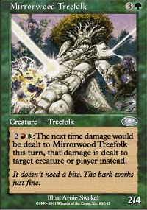
Right after the victory the two artists on site, Glen Angus and Arnie Swekel came up and gave me the original sketch for Quagmire Lamprey and Mirrorwood Treefolk as well as a painting of the Treefolk. I thought Brock deserved something extra for his efforts so I passed the painting along to him. Not having trophies at the North American Grand Prix makes me appreciate the gifts of art even more. It adds some flavor to the event and I really like it. I encourage future artists to contribute prizes as well. I expect they will be appreciated.
It was an incredible relief to win the event after making so many mistakes. If I had lost the event because of a mistake I would probably have spent the next six months agonizing over it and losing confidence. As it is, I feel great and I still grin when I think about winning. Grand Prix Dallas seemed like a bit of a fluke, but having made three Top 8s at Grand Prix this season, I'm starting to think I'm doing something right!
So why am I winning? What's the secret to my success?
It could just be that I have a gift for winning Grand Prix in cities starting with "D." With that in mind there's no point in going to Grand Prix-Denver in August unless you're happy with second place!
Alternatively, it could have to do with the fact that I've won the two Grand Prix that were held on weekends where daylight savings time went into effect. I gained an extra hour in Dallas and won, I lost the hour in Detroit and won. I'll be keeping an eye on ye olde lunar calendar after this, I can assure you!
I could just be that I'm the "Anti-Shvartsman" - he always wins in Europe but has trouble in North America, I'm the exact opposite. And neither of us can get our game on for the Pro Tour! If there were a way to combine our powers into one being we'd be unstoppable!
A more "out in the park" idea I had over the past week has to do with print runs. I was never very good at remembering the print runs, so I was probably at a disadvantage at high level drafts. But WotC changed the print run schemas so they aren't as consistent or predictable so now everyone is at an even footing. I suspect that this has helped me a lot more than it has helped others, but I can't be sure.
It may just be that I understand sealed deck more than most people. I didn't make Top 8 at Pro Tour-Atlanta on good looks alone! Going 7-1 or 8-0 on the first day is critical to making Top 8 and you need to be up on your sealed deck play to do it. People don't tend to practice sealed deck and I think it hurts them. For example, too many people still play first in sealed and that's wrong. The slower nature of a three-color format often makes card advantage a critical factor in who wins and drawing the extra card means you'll be ahead after a battle of attrition. You lose a bit of the early game but that's not as painful in sealed as it is in draft or constructed.
I'm not really sure why I'm doing so well in Invasion Block Limited events, and we'll see if I can keep it up at Pro Tour-Barcelona next month. I know that until then I'm going to try and practice my play a lot more to minimize mistakes. I'm also going to cut back on the trash talking so I concentrate on my games more. Hopefully I'll finally be able to throw off the "winner by accident" label that I've earned over these past few months!

